Industrial UHF handheld rfid reader (Android 13)
Ultra-Long Range | Massive 9600mAh Battery | Professional Data Capture
Product Overview
This high-performance industrial grade handheld rfid reader is designed specifically for large-scale material management, intelligent warehousing, and complex logistics environments. Equipped with the latest Android 13 operating system and an efficient 8-core 2.0GHz processor, it not only provides an extremely smooth running experience, but also integrates industry-leading UHF RFID and 1D/2D barcode scanning technology.
The most significant advantage of this device is its 9600mAh ultra large capacity battery, which can provide more than 12 hours of continuous working time, completely solving the pain point of endurance for high-intensity operations. The built-in Impinj E-series chip ultra-high frequency RFID module, paired with a 4dBi circularly polarized antenna, achieves a stable reading distance of up to 20 meters and a group reading rate of up to 2000 tags per 10 seconds, significantly improving asset inventory efficiency.
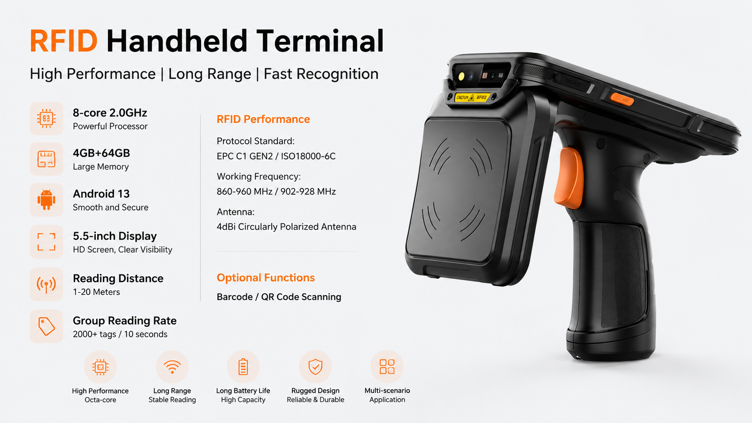
Key Highlights
- Powerful RFID Performance: * The built-in Impinj E-series chip ultra-high frequency RFID module (optional).
  - Achieves a remarkable reading distance of 1–20 meters.
  - Support for high-speed group reading at a rate of 2,000 tags per 10 seconds.
- Massive Battery Capacity: * Features a 9600mAh polymer lithium battery.
  - Supports 18W fast charging, with a standby time exceeding 350 hours.
- Modern Operating System & Hardware: * Runs on Android 13 with an 8-core CPU (up to 2.0GHz).
  - Features a 5.5-inch industrial-grade capacitive touch screen (720*1440 resolution).
  - Standard 3GB+32GB memory, expandable up to 256GB via Micro SD.
- Professional Data Capture: * Integrated professional scan engine for all major 1D/2D barcodes.
  - High-definition 16MP rear camera with autofocus and flash.
- Industrial Durability: * IP67 rated for superior dust and water resistance.
  - Built to withstand multiple 1.2m drops to concrete.
  - Operates in extreme temperatures from -20°C to 55°C.
- Comprehensive Connectivity: * Supports 4G LTE, Dual-band WiFi (2.4G/5G), Bluetooth 5.0, and high-precision GPS/Galileo/Glonass/Beidou positioning.

Typical Applications
- Inventory & Warehouse Management: Rapid inventory counts for large-scale retail or logistics hubs.
- Asset Tracking: Long-range identification of equipment and high-value assets in industrial environments.
- Supply Chain Logistics: Real-time data synchronization for transit and distribution.
- Utility & Field Service: Reliable operation for outdoor inspections and infrastructure maintenance.

Structure Parameters
- Dimensions: 171mm * 88mm * 138mm
- Weight: 680g
- Standard Accessories: Adapter, data cable, protective film
Basic information
processor | 8 core CPU ARM 4×A53 2.0GHz+4×A53 1.5GHz
Operating system | Android 13
( RAM +ROM) | 3GB+32GB (standard), 4GB+64GB (optional)
Expand memory | Micro SD block, Maximum support 256GB
display screen | 5.5 inch resolution ratio 720*1440
Touch screen | Industrial grade capacitive screen,Multi touch support
Rear Camera | 1600W Pixel HD camera,Supports autofocus.flash lamp
front camera | 500W Pixel camera (optional)
audio frequency | Built in microphone * 1  Speaker (1.2W) * 1,  Earpiece * 1
prompt | Vibration prompt/LED prompt/audio prompt
keyboard | 6 keys in total: 2 side scan keys, 1 side power key, volume+/- keys, and handle buttons
cassette | nano SIM card *2& nano SIM card x 1 + T_FLASH * 1
sensor | Light proximity sensor, gravity sensor;
battery | 9600mAh polymer lithium battery  Standby time>350 hours  Working hours>10 hours (depending on usage environment)  Supports 18W fast charging  Charging time 3-4 hours, using standard power adapter and data cable
Charging method | Type-C charging, 5V 2A
Communication transmission
USB interface | Type-C USB x 1,Support OTG function
WLAN function | Dual band 2.4GHz/5GHz, supporting IEEE 802 a/b/g/n/ac protocol
Bluetooth | Support Bluetooth 2.1+EDR/3.0+HS/4.1+HS+5.0
GPS | Support GPS,Galileo,Glonass,Beidou
Wireless Wide Area Network (Data Services) | GSM/GPRS/EDGE/CDMA/UMTS/HSPA/HSPA+/WCDMA/TD-SCDMA/TDD-LTE/FDD-LTE
Wireless Wide Area Network (Network Frequency) | 2G:GSM( B2/B3/B5/B8)  3G:WCDMA( B1/B2/B5/B8)  4G:FDD:B1/B2/B3/B5/B7/B8  TDD:B34/B38/B39/B40/B41
UHF RFID
UHF RFID | Ultra high frequency module, readable and writable, distance 1-20 meters  Operating frequency (860-960 MHz, frequency band can be customized according to requirements)  Chinese frequency: 920-925 MHz  US frequency: 902-928 MHz  Other frequencies: Other multinational frequency standards (customized)  Protocol standards: EPC C1 GEN2/ISO18000-6C, GJB7377.1A-2018 (optional)  Antenna: 4dBi circularly polarized antenna, designed using the four arm spiral principle  Reading distance: 1-20m (depending on the label and actual environment)  Group read rate: 2000 tags/10 seconds
Optional RFID module | Built in Impinj E-series chip ultra-high frequency Rfid module
scan engine
Optional | Barcode, QR code scanning
Environmental parameters
operation temperature | -20℃~55℃  *For safety reasons, do not charge in low temperature environments
storage temperature | -40℃~70℃( Without battery)
humidity | 0~95%( No condensation)
Drop specifications | 1.2 meters of cement ground has fallen multiple times
protection grade | IP67( Only for the host part, excluding shield and handle)
Electrostatic Discharge | ±15KV( air discharge),±8KV( Contact discharge)
development support
development language | Java
Develop API | Android standard interface
structure parameters
Size( mm) | 171mm *88mm *138mm
weight | 680g
Equipment accessories
Standard accessories | Adapter, data cable, protective film
optional | Charging dock

Provide ODM and OEM customized services
• We work closely with our partners and can provide various one-stop customized solutions.
• Appearance customization: supports customization of product nameplates, product packaging, and promotional materials.
• Hardware customization: Supports customization of functional modules and optional hardware functions.
• Software customization: supports customization of boot interface, boot program, kernel clipping, and API interface.
• Technical support: Provide SDK development kits and application software development technical services.

